Week 6 day 5-Friday(13th November)
Agile methodology-class demo notes
Project- planning a copy of amazon
-need to plan what we need to build and the pieces to be built
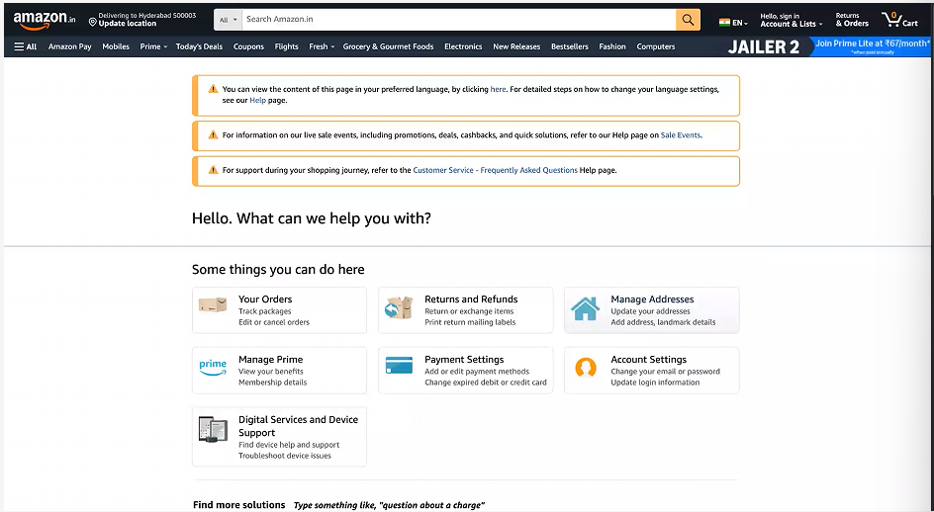
This is customer service portal of amazon.
We work with amazon, we need to build this page.
Got a wireframe from the client/product dev team.
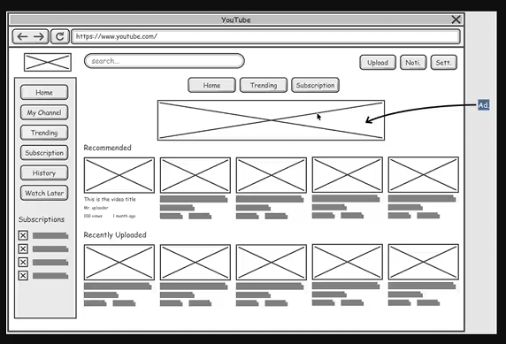
This is youtube wireframe, basic idea of what the product should look like. Product owner decides this. A wireframe is generally black and white.
The architect and tech lead breaks down the page wireframe into pieces to understand it so that it can allocated to the engineering team.
Back to amazon, the user should be able to track order, return/refunds, manage address(multiple), etc.
Let there be 20 people in the team, can we build this in 30 days? NO. the user number is very high.
Tracking interface-
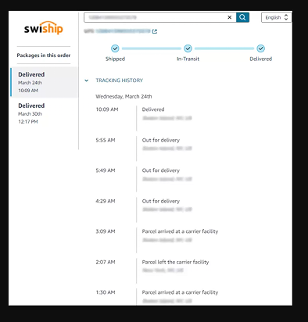 journey of the products
Complicated algorithm because the journey and tracking is complex.
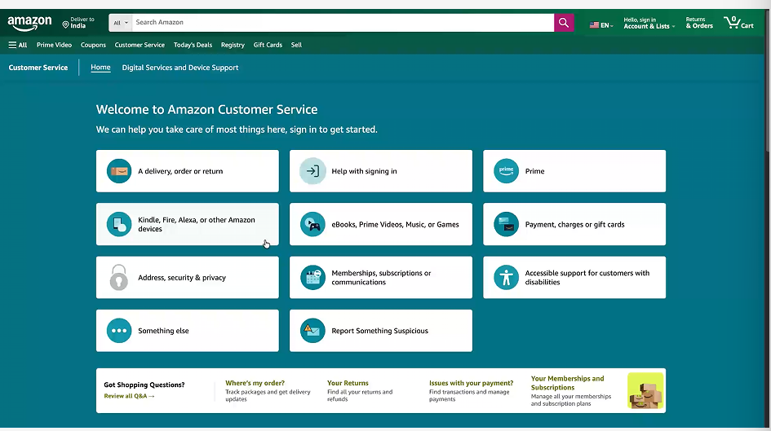
Largest user base for multiple companies is india.
Stress testing, load testing etc required fir building the “ your orders” etc features, cannot move on from development phase.
Anything that takes more than a month to build from agile perspective- EPIC –CUSTOMER SERVICE PAGE
THE epic has to be broken down into features-
Features are-
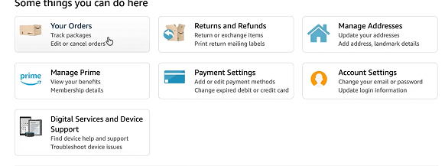
Features have to be broken down into user stories
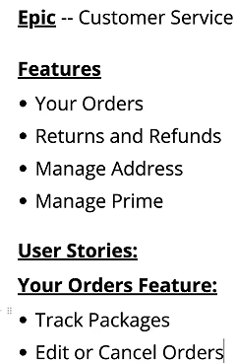
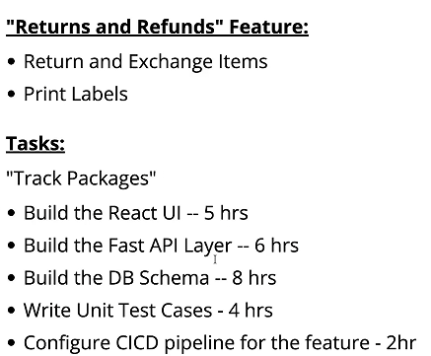
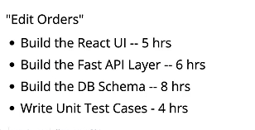
Assign each task to diff engineers they work in parallel

